University POLITEHNICA of Bucharest
Faculty of Engineering & Management of Technological Systems

Study programme: Industrial Engineering (in English)

DIPLOMA
PROJECT

Author,

Graduate ………………………………….

Scientific coordinator,

………………………………………………………….

2017
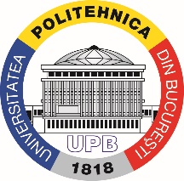 | University POLITEHNICA of Bucharest  Faculty of Engineering & Management of Technological Systems  (021) 4029520, (021) 4029302/ Fax: 0213107753  http://www.imst.pub.ro

Bachelor studies

Domain Industrial Engineering
Study programme: Industrial Engineering (in English)

DIPLOMA PROJECT
THEME

................................................................................................................................................................................................................................

Author,

Graduate …………………………

Scientific coordinator,

………………………………………………

Dean,

Prof. Cristian DOICIN, PhD

2017

